- Execute all scripts from the devops-cloud-documents- channel.
Condition command
EXample 1
Tried with 100
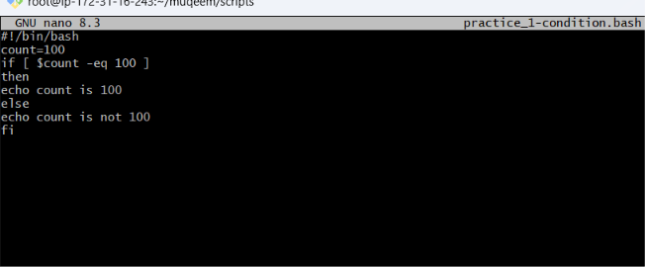
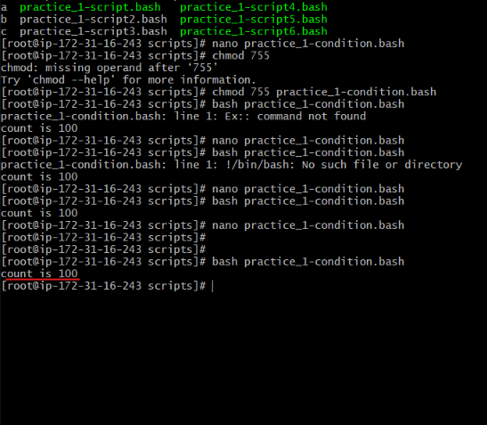
Tried with other then 100
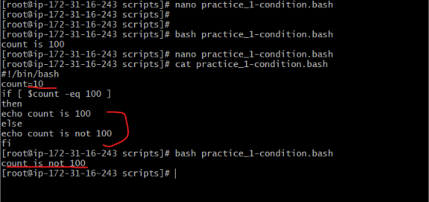
Example 2
Checking the the file with wrong file name
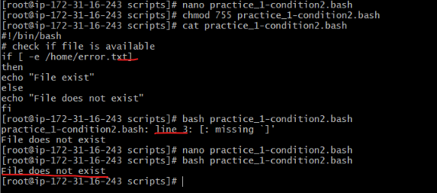
Checking the the file with correct file name
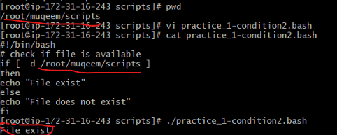
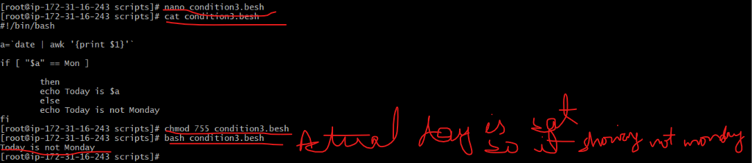
Case statement with correct and incorrect input
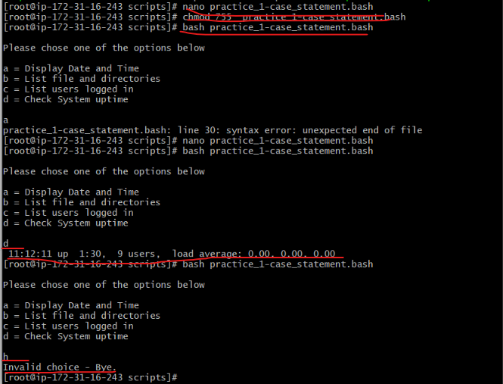
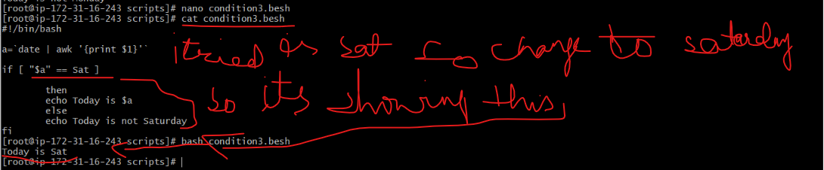
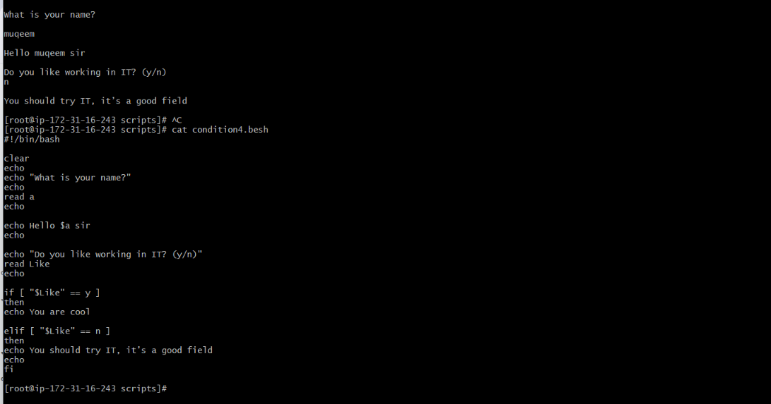
Loop Scripts
Example 1
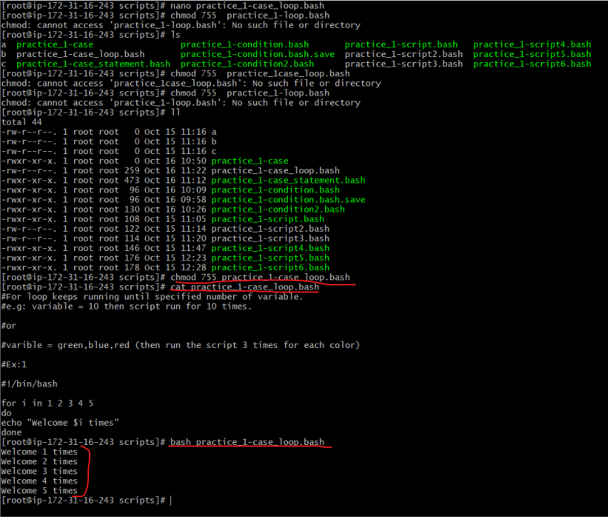
Example 2
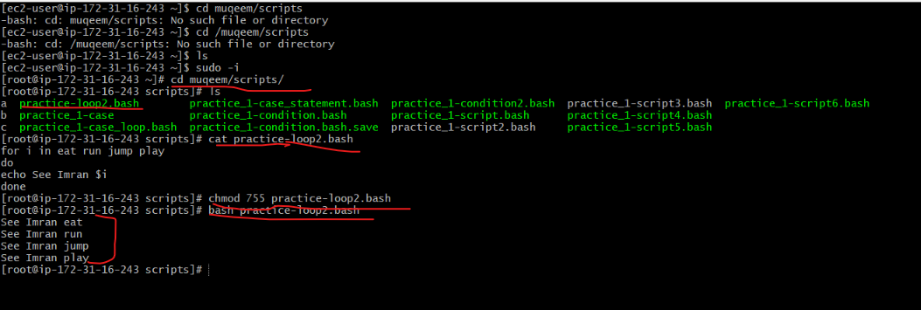
Example 3 : creating 5 files by looping
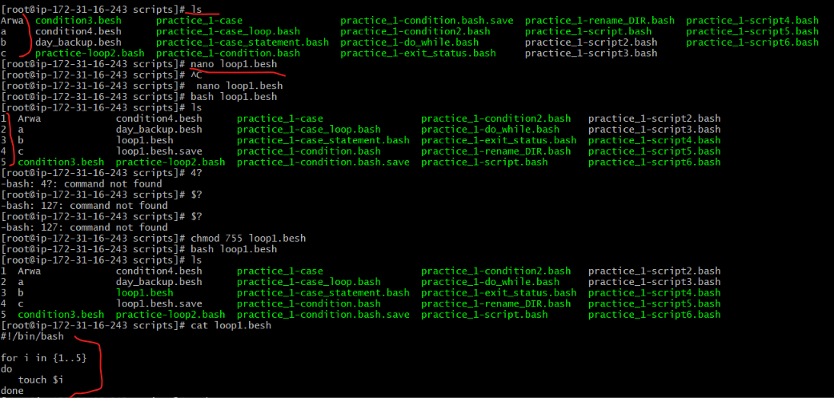
Example 4 removing files by using looping
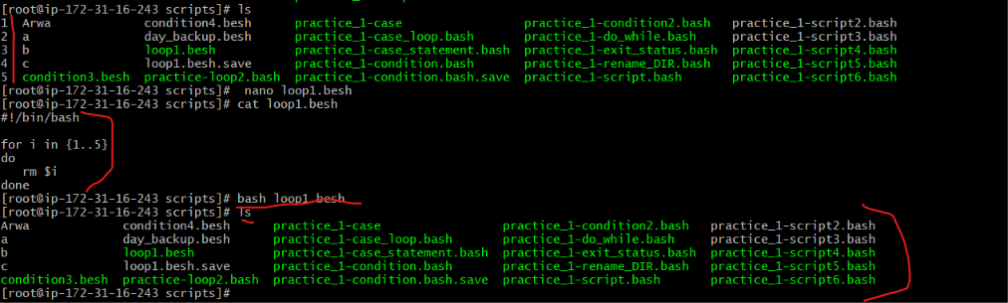
Do-while scripting
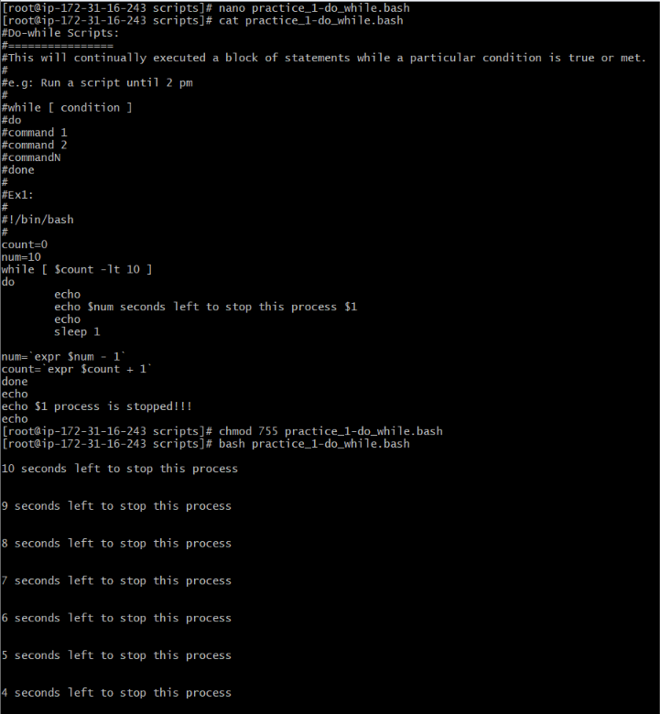
Exit status with successful command
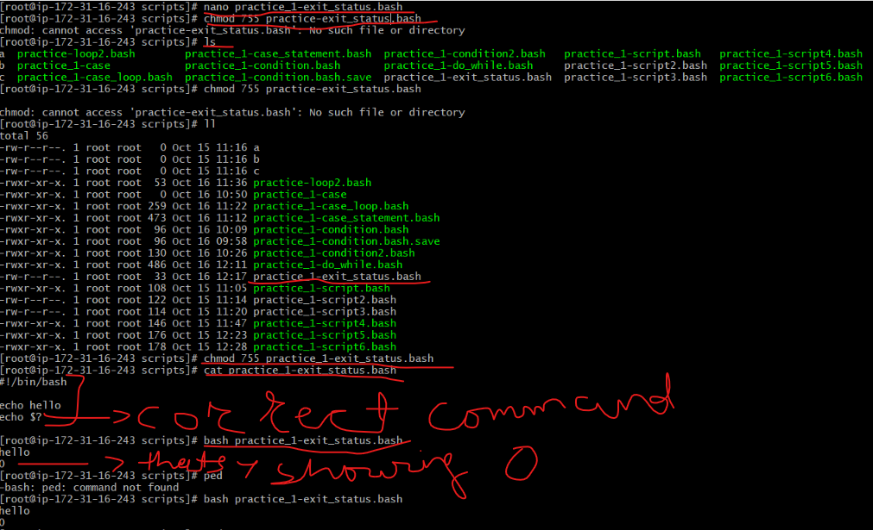
Unsuccessful command
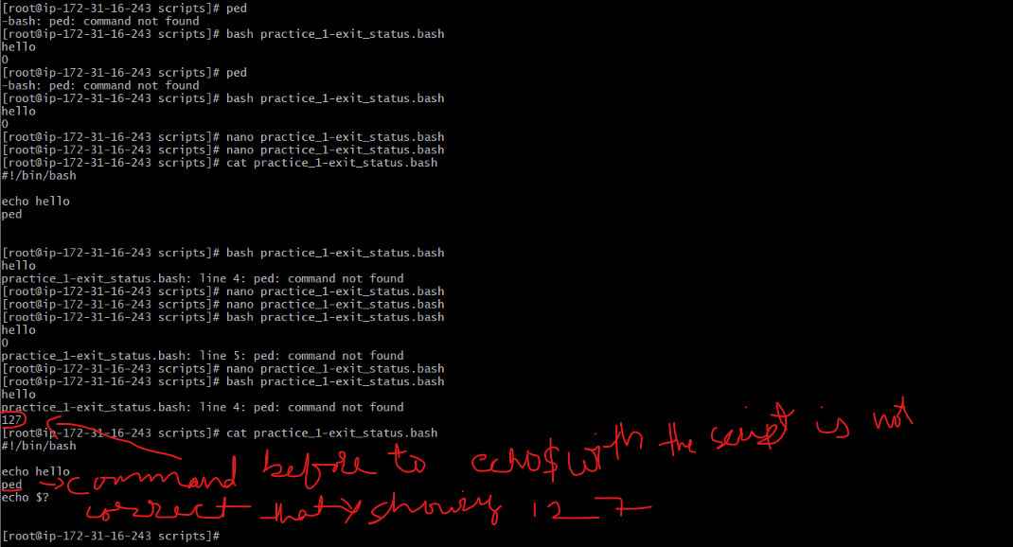
Ex3:
- Return exist status if file exist
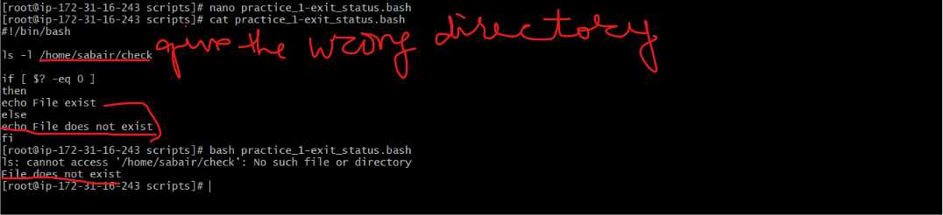
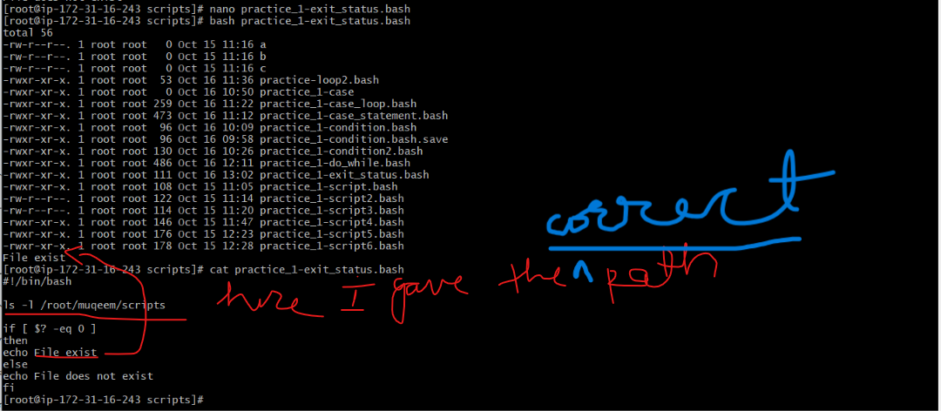
Renaming the folder name
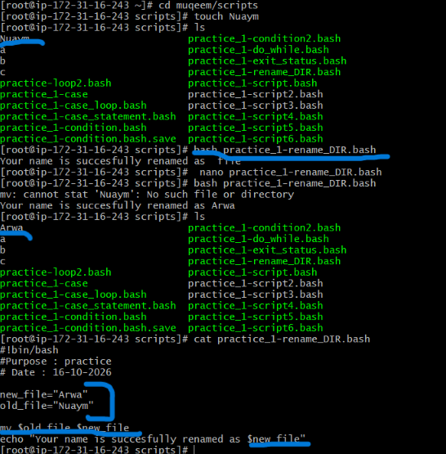
your current day and tell you the state of the backup:
1. tried on Friday so it is showing partial backup

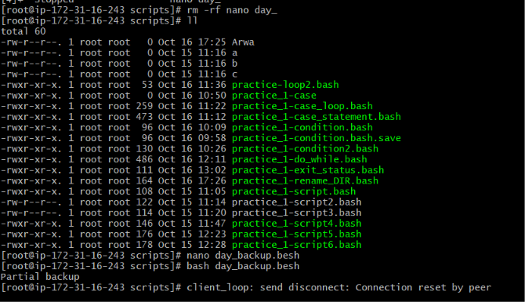
2. tried on saturday so it is showing no backup
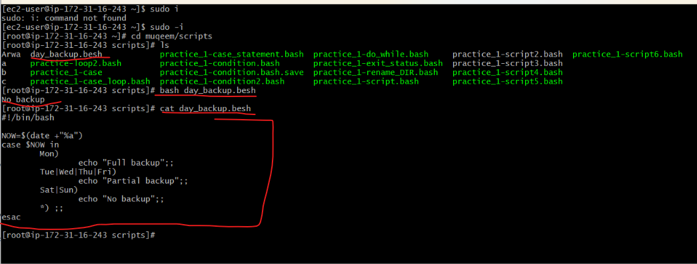
Cronjob set to execute on 09:04pmIST 18-10-every year
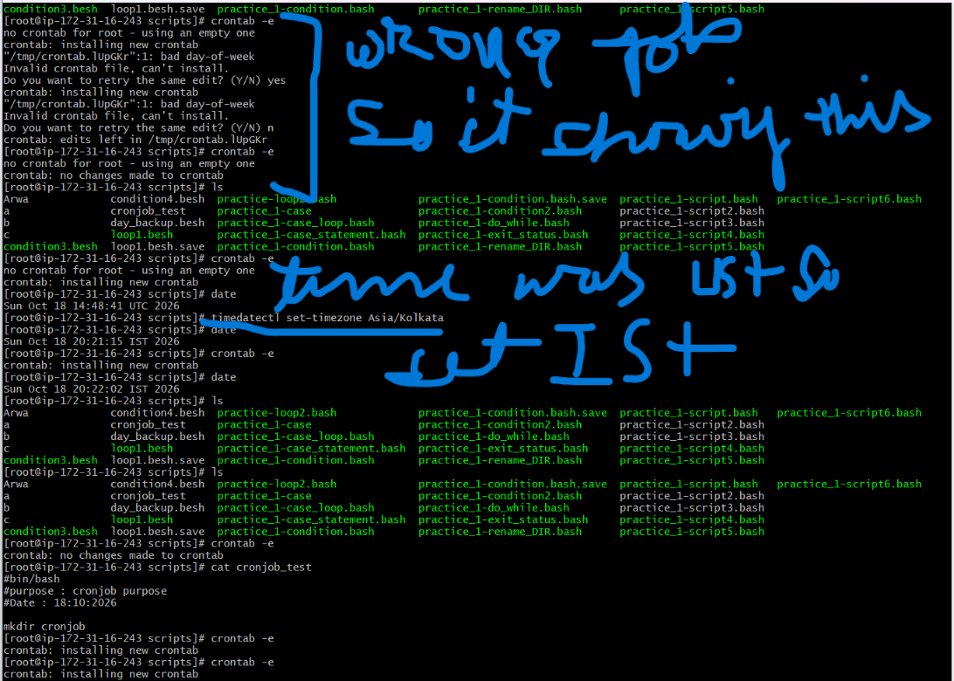
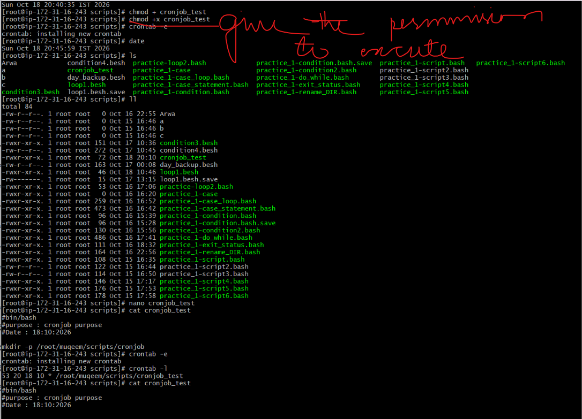
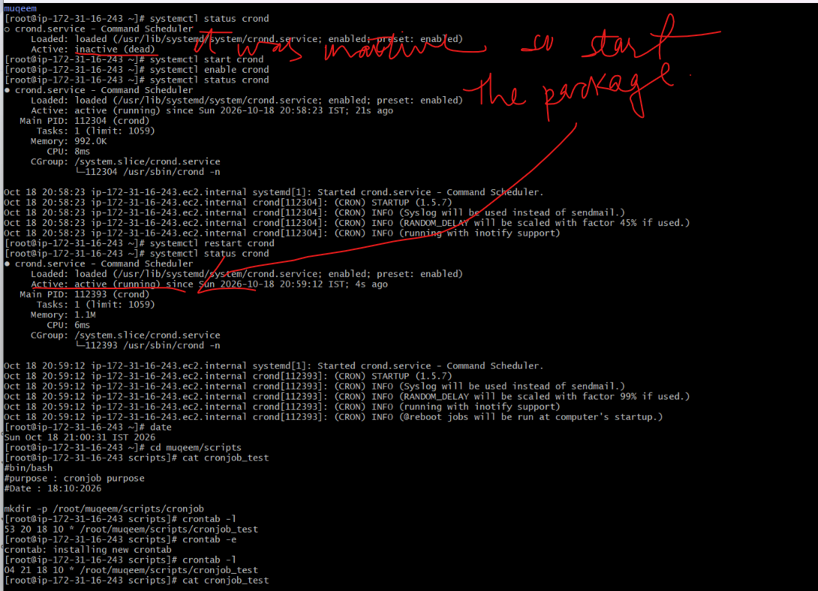
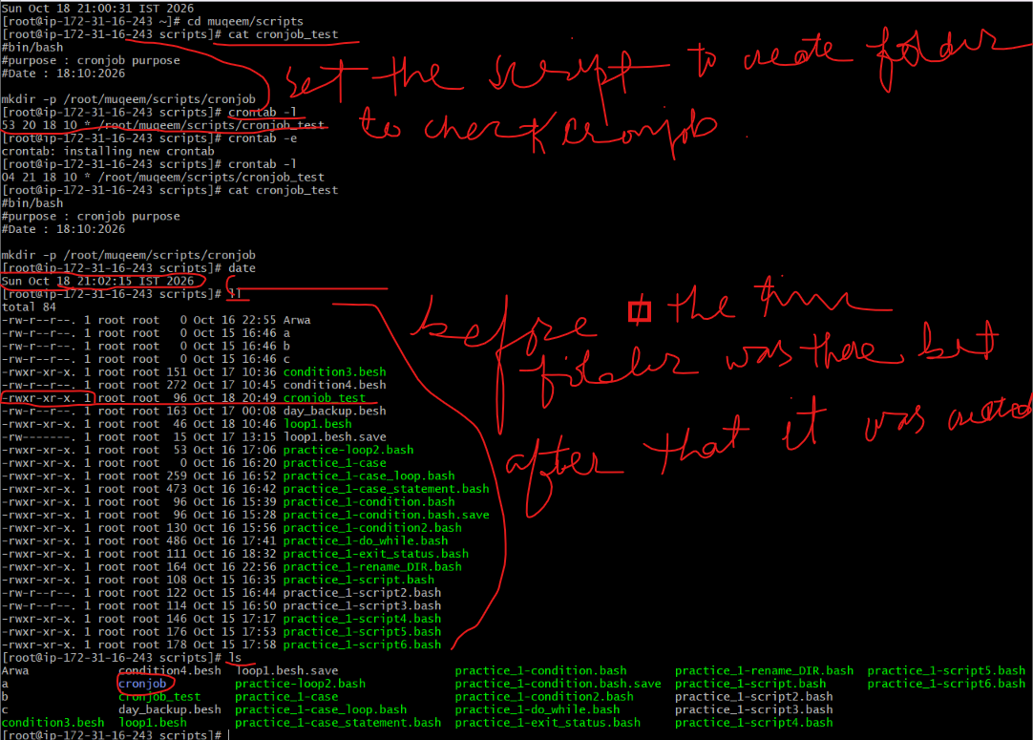

Bash Script Tasks
- Create a bash script to check if a directory is available or not.
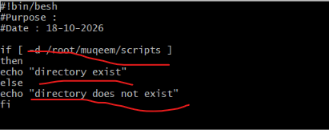
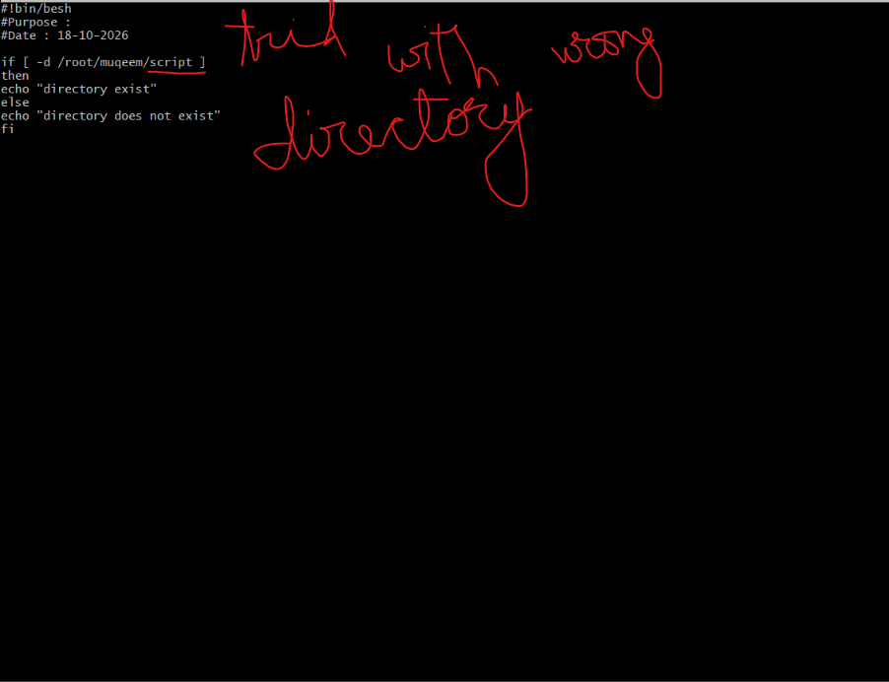
- Create a bash script to create multiple files.
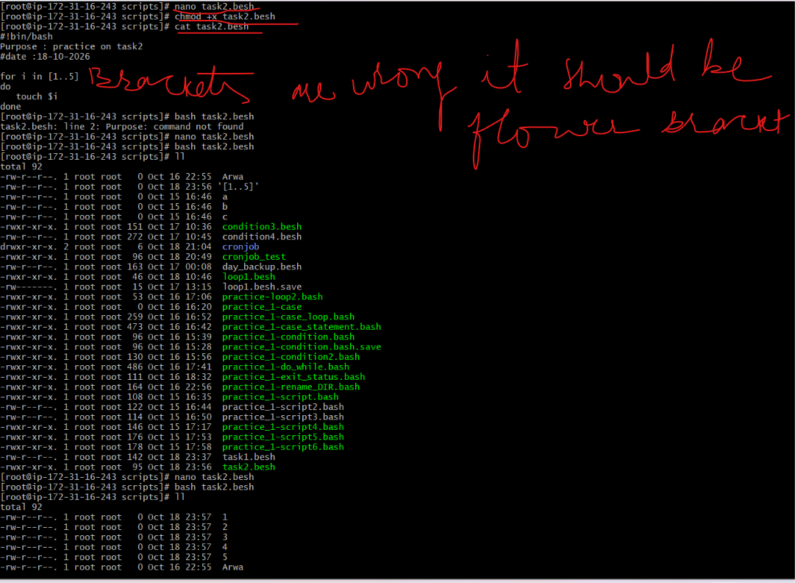
- Create a bash script to take a backup of a directory.
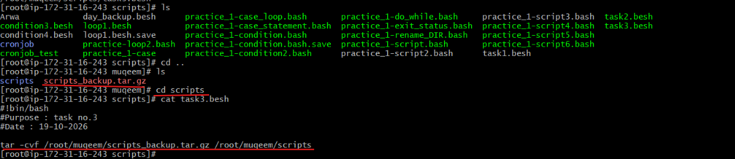
- Create a bash script to install Nginx on an EC2 server.
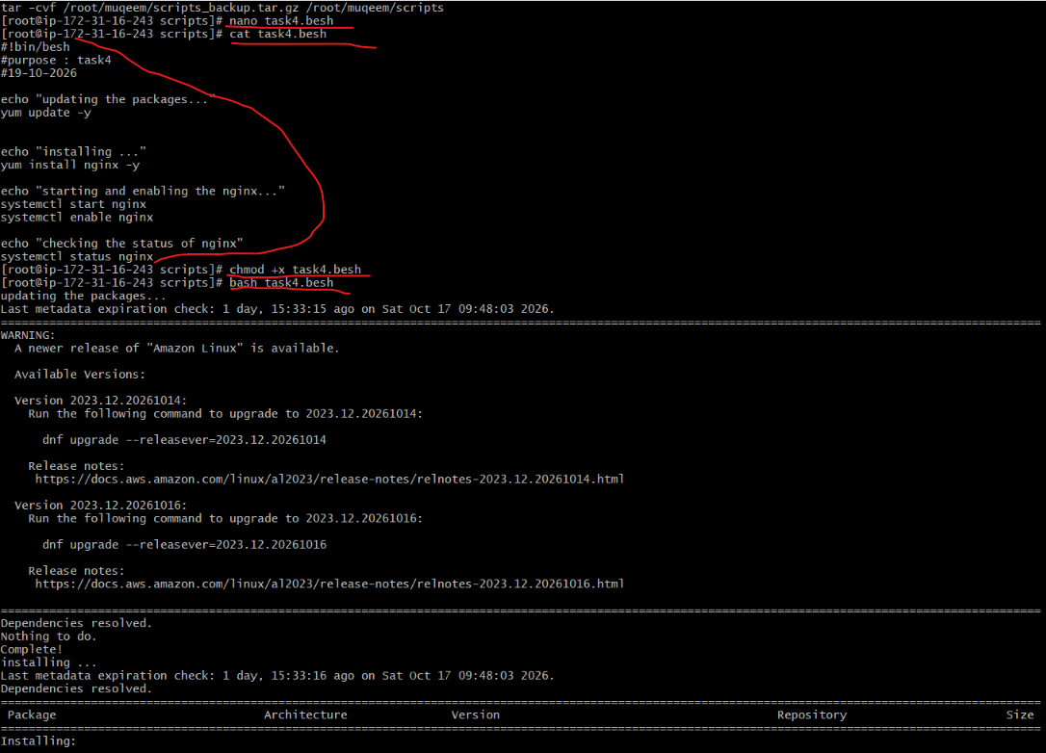
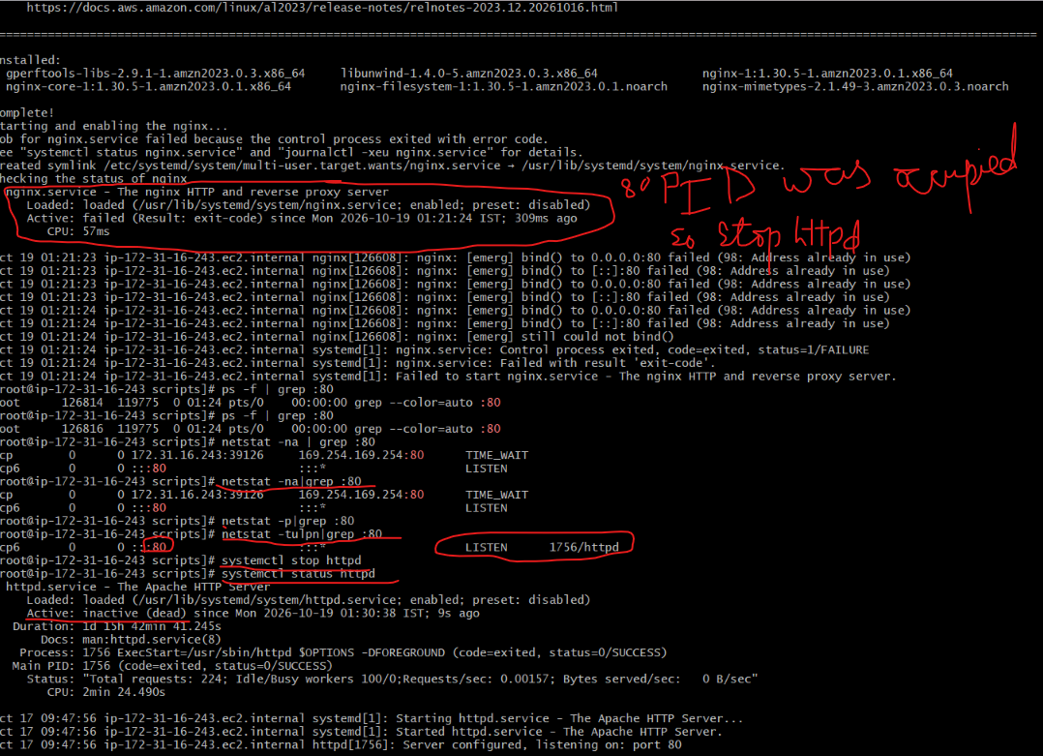
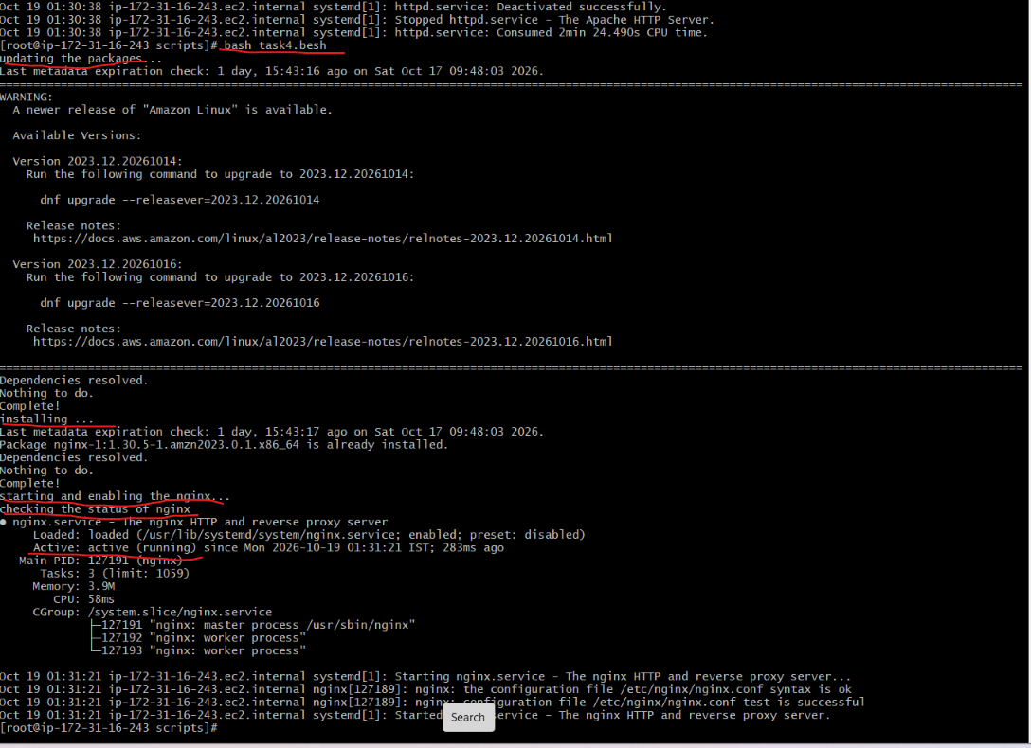

- Create a bash script to install Apache Tomcat on an EC2 server.
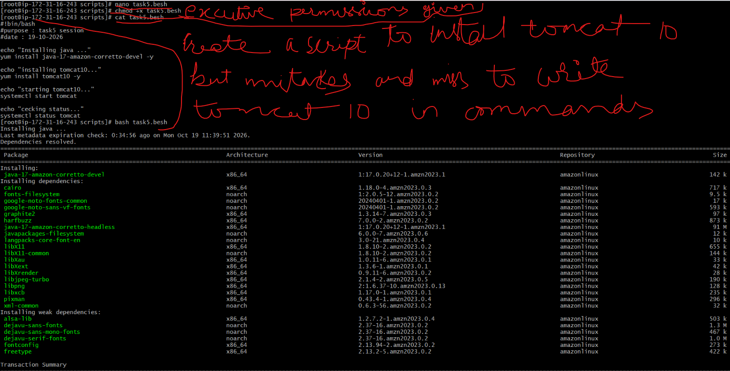
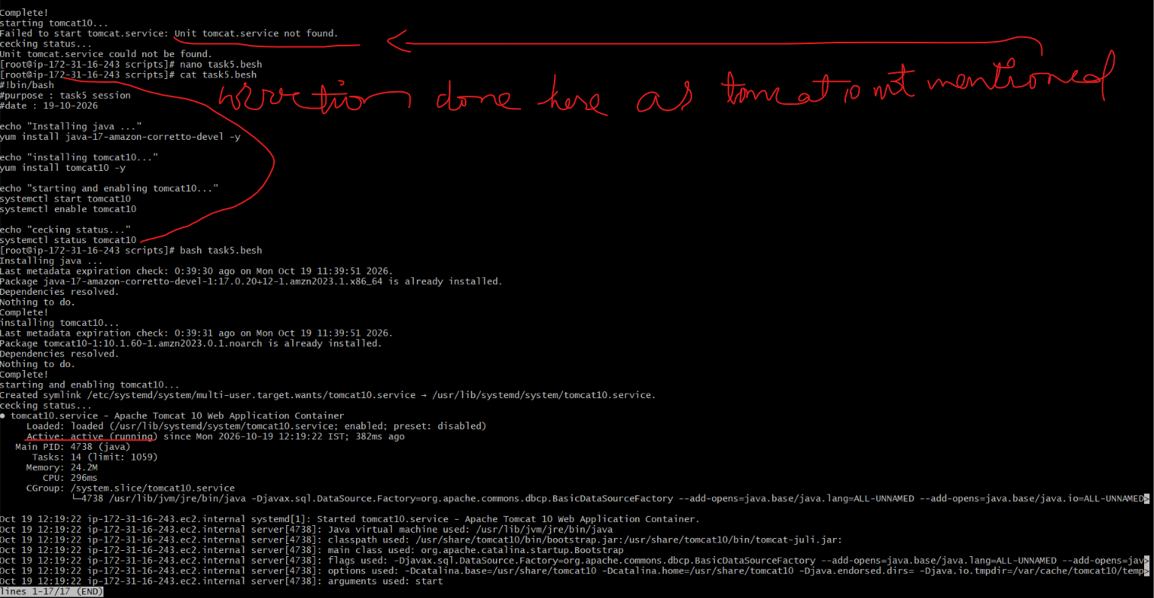

- Create a bash script to check if the Nginx service is running, if not running then script should start the service.
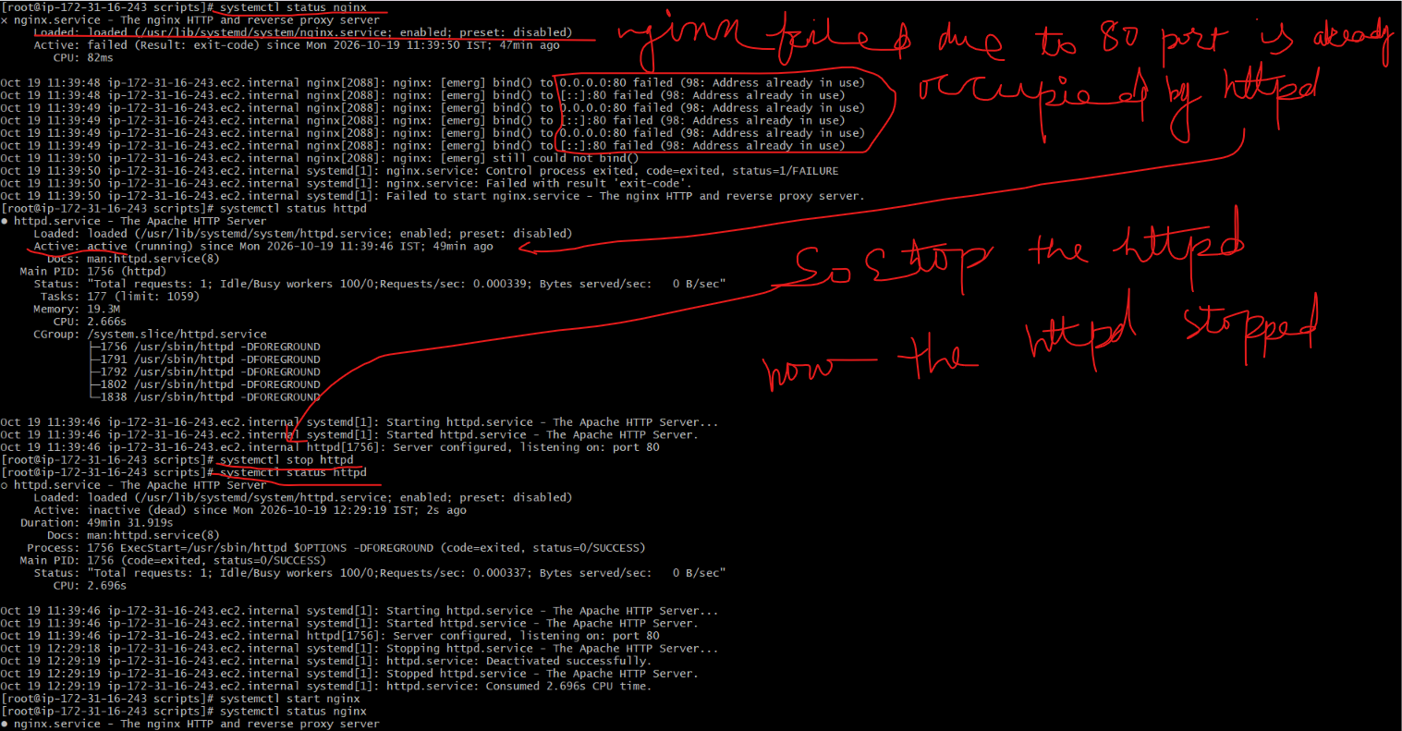
Nginx was stopped before execution of this script and exit code was non 0 then i execute this script and now the nginx run successfully
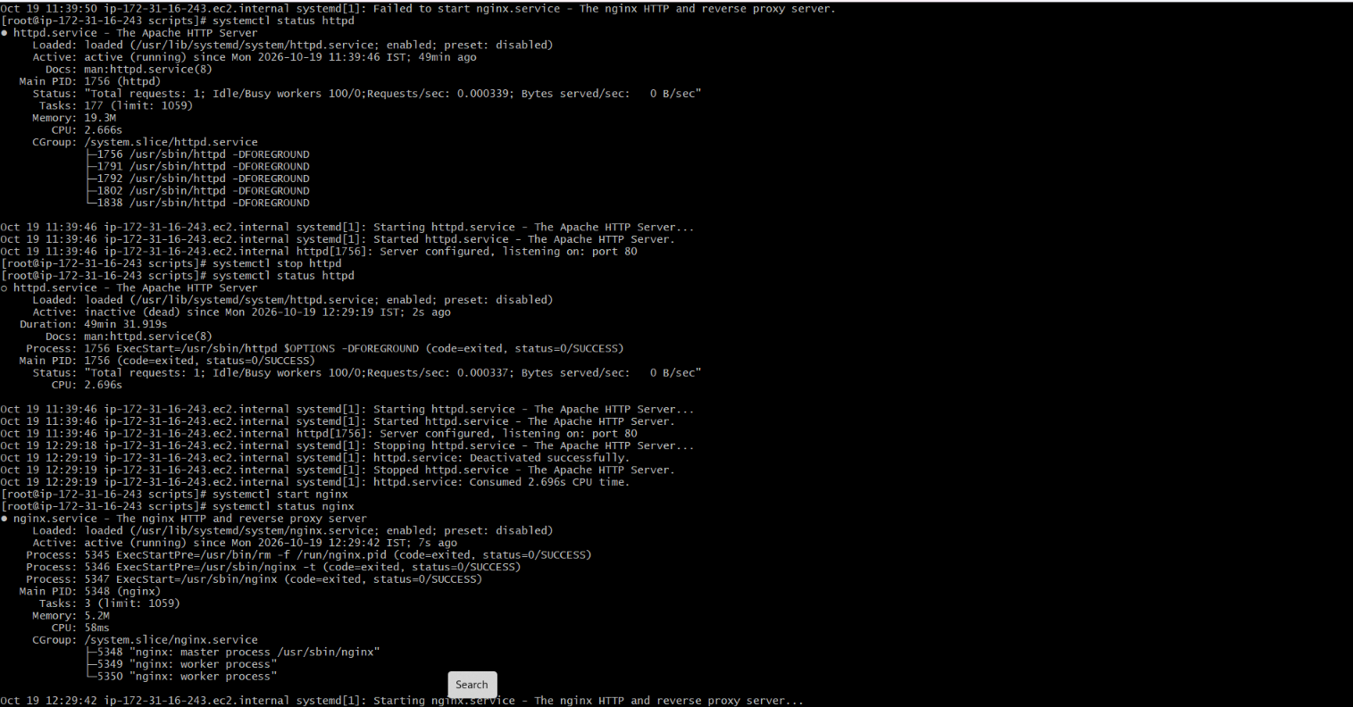
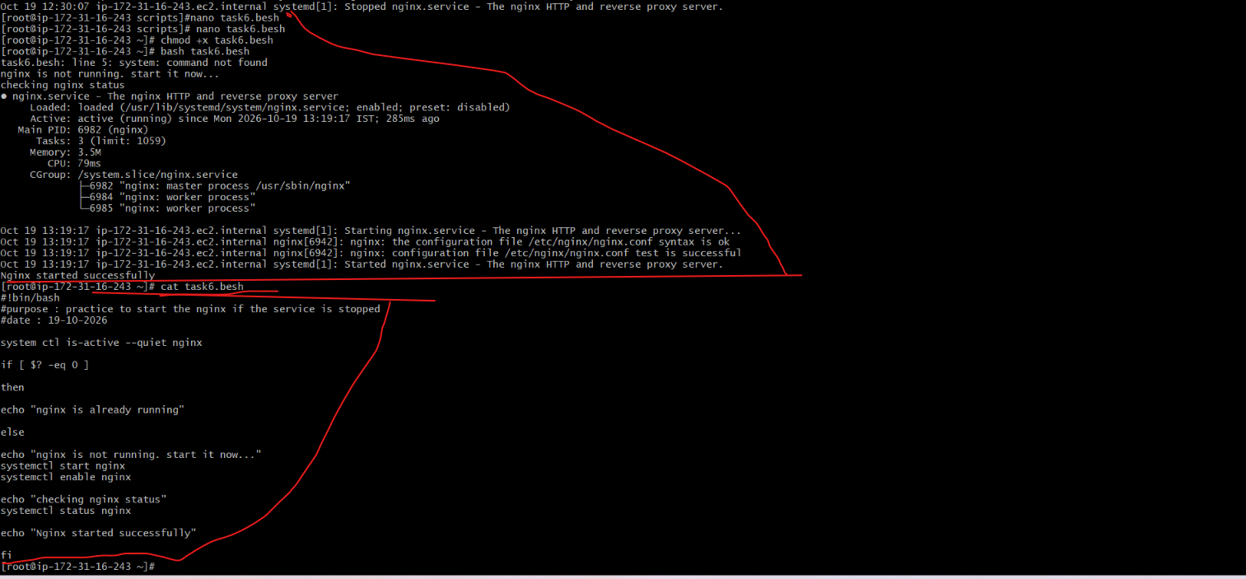
We will what will happen if it is already is active and exit code is already 0
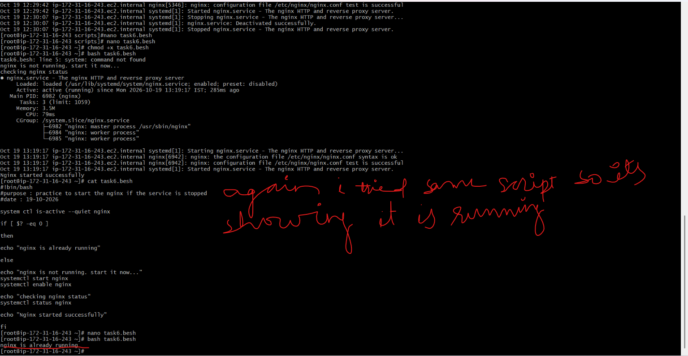

- Create a bash script for a calculator.
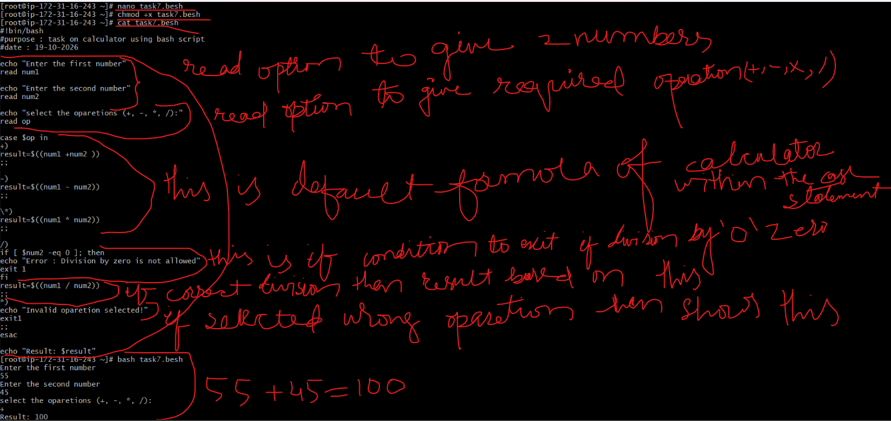
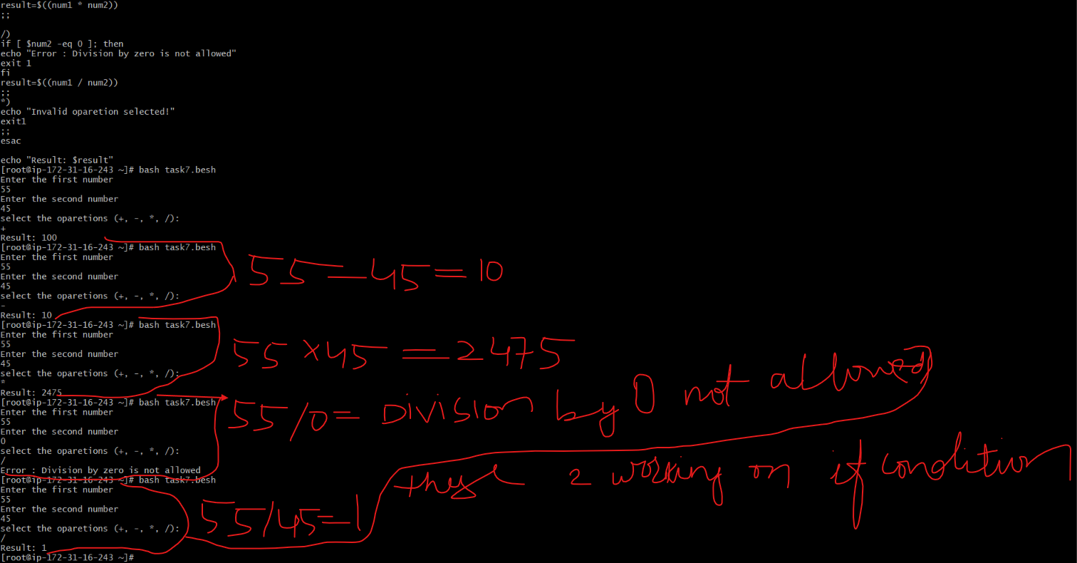

- Create a bash script to check if a directory exists, if not then create a directory.
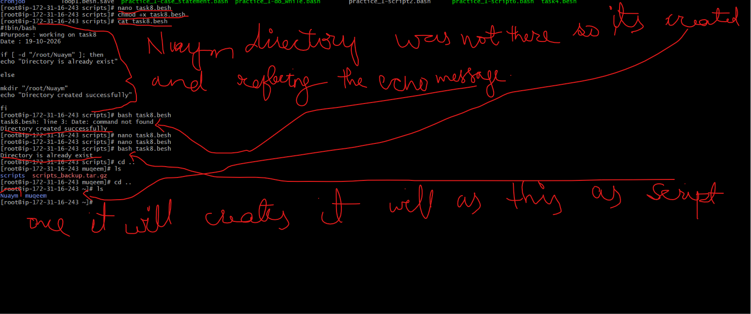

- Create a bash script to delete the last 3 lines of a file.

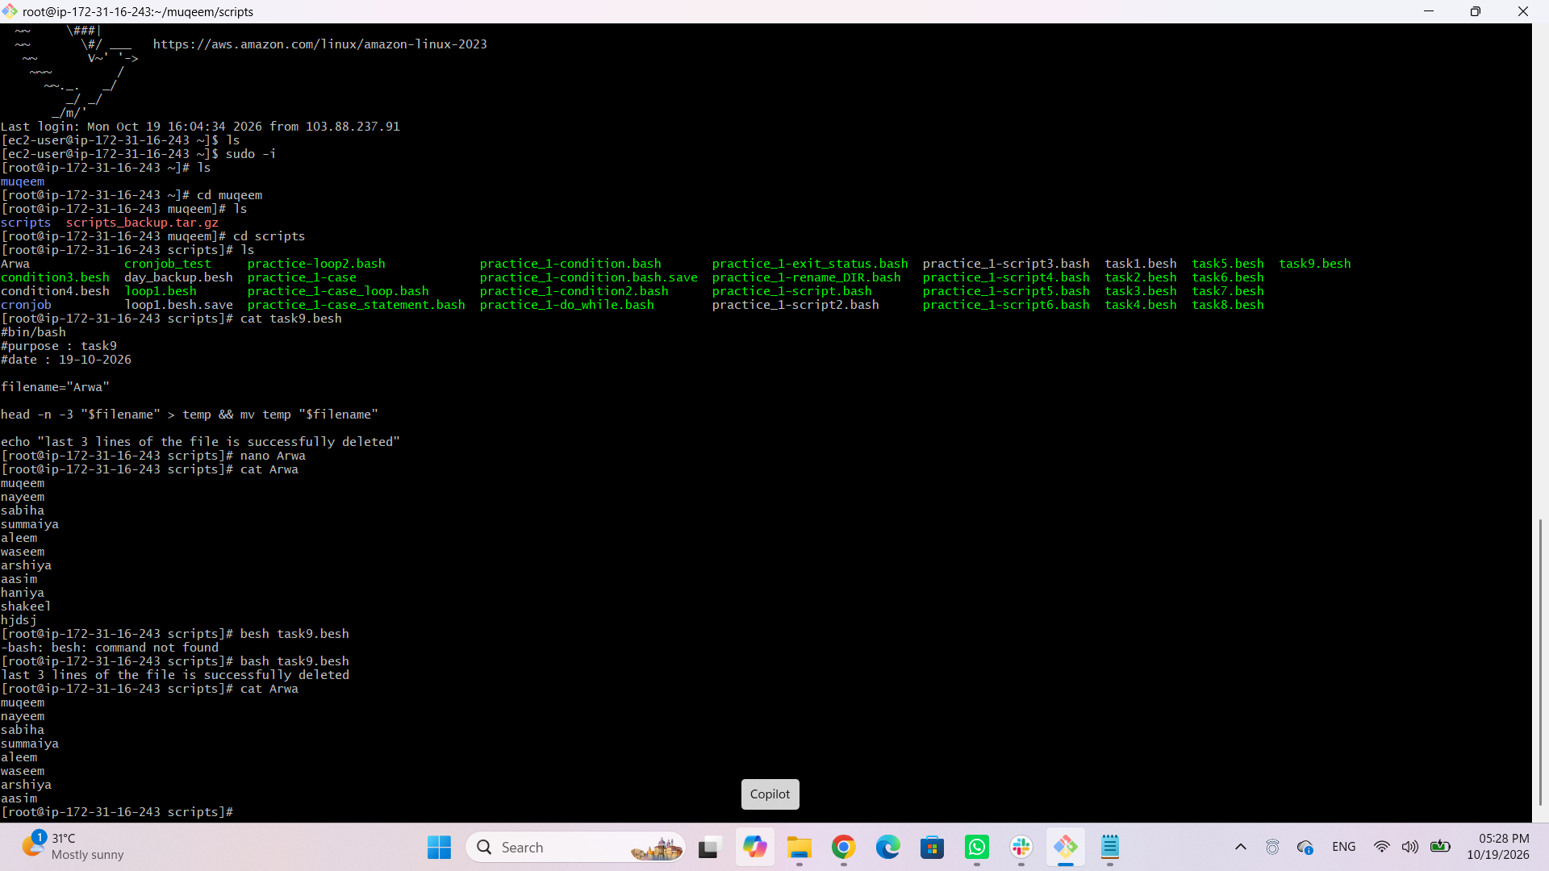
- Bash script to monitor cpu and if it is more than 80% then send email notification.
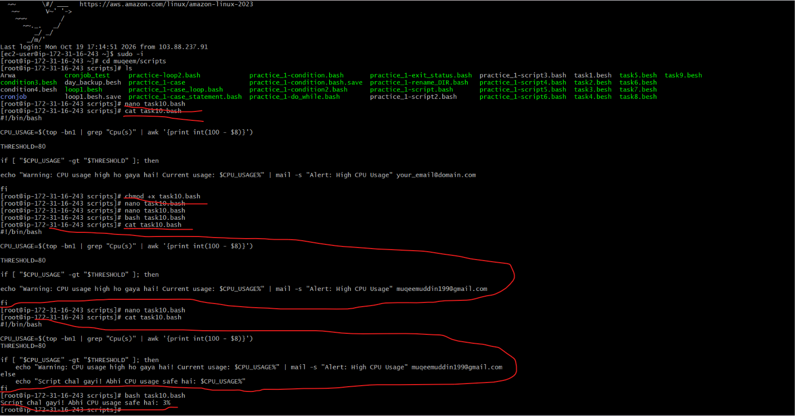
Example 2 : my actual CPU is just 3% so reduce the percentage from 80% to 2% to receive an email :
Install mailx service to get an email
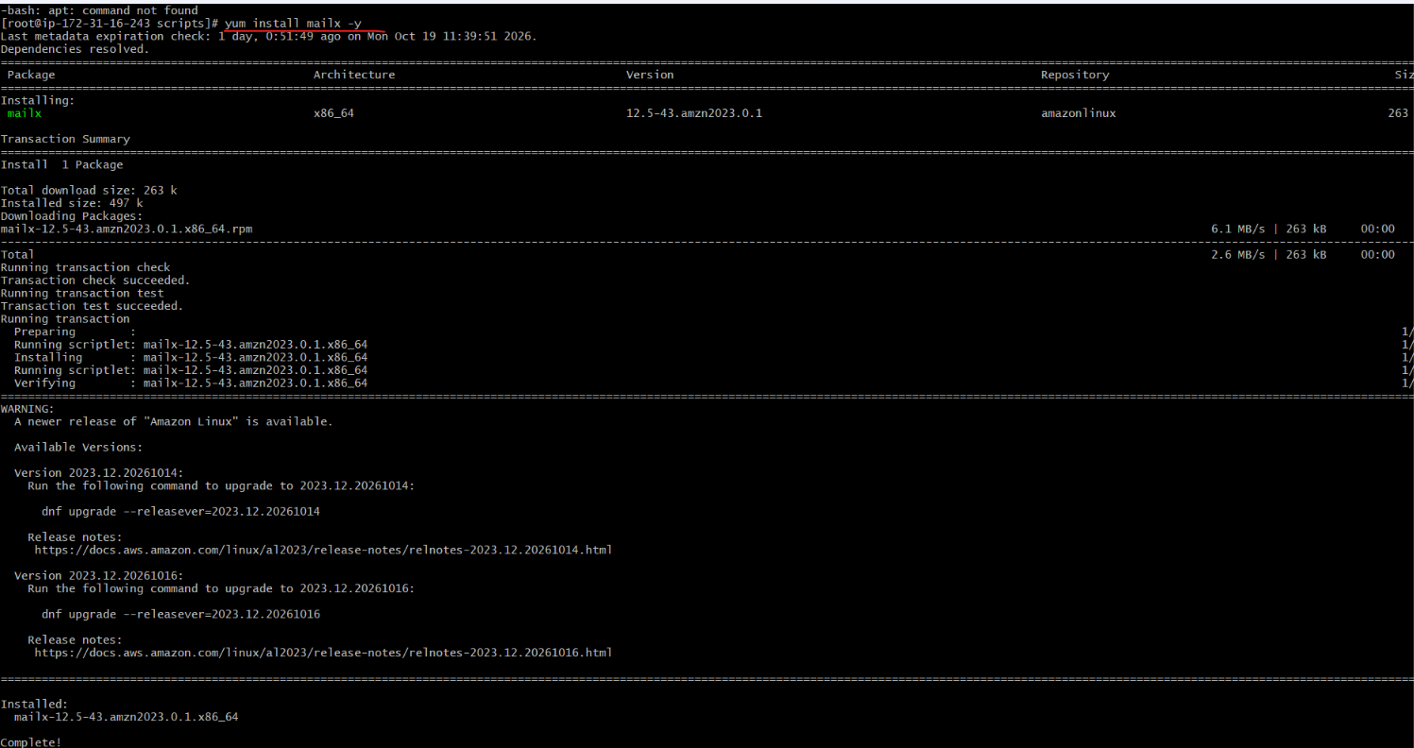
Then followed this steps so that i can get a email :

Important Note for AuthPass:
Here, you do not need to enter your normal Gmail password. Due to security reasons, Google requires an App Password:

- Go to your Google Account settings -> Security.

- Turn ON 2-Step Verification.

- Search for App Passwords and generate a new password (e.g., abcd efgh ijkl mnop).

- Enter that 16-character code after AuthPass=.

Then paste this script in my bash script file:
#!/bin/bash

CPU_USAGE=$(top -bn1 | grep "Cpu(s)" | awk '{print int(100 - $8)}')
THRESHOLD=2

# Display current CPU usage on screen
echo "Current CPU Usage: $CPU_USAGE%"

if [ "$CPU_{U}SAGE"-gt"$THRESHOLD" ]; then
echo "Warning: High CPU usage detected! Current usage: $CPU_USAGE%" | mailx -s "Alert: High CPU Usage" \
-S smtp="smtps://smtp.gmail.com:465" \
-S smtp-auth=login \
-S smtp-auth-user="muqeemuddin199@gmail.com" \
-S smtp-auth-password="vpye kxhu merj ggdd " \
-S ssl-verify=ignore \
muqeemuddin199@gmail.com

echo "Email alert sent successfully!"
else
echo "CPU usage is within the safe limit."
fi
Then executed the script so got mail as well as result on my terminal
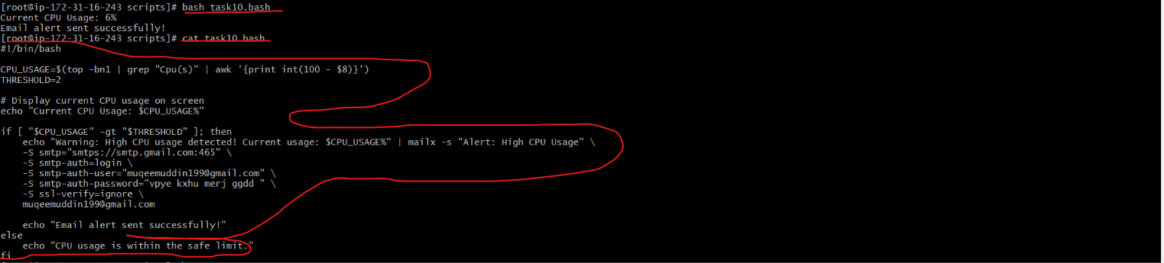
Email alert
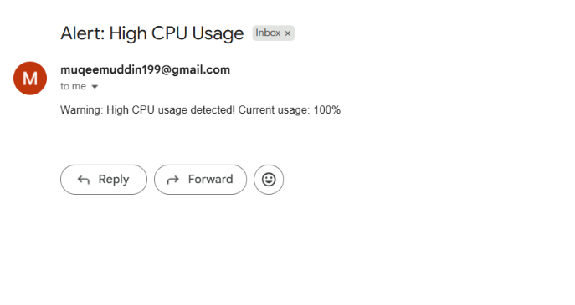

- Bash script to monitor disk space and if it is more than 80% then send email notification.
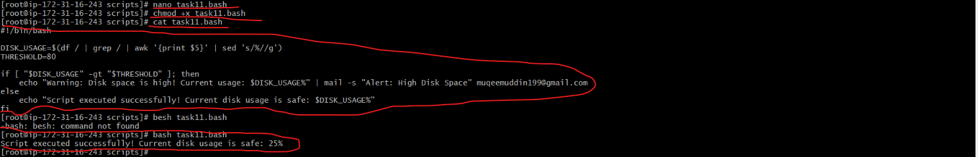
Example 2 : my actual disk space is just 25% so reduce the percentage from 80% to 25% to receive an email :
Install mailx service to get an email
Install mailx service to get an email
Then followed this steps so that i can get a email :

Important Note for AuthPass:
Here, you do not need to enter your normal Gmail password. Due to security reasons, Google requires an App Password:

- Go to your Google Account settings -> Security.

- Turn ON 2-Step Verification.

- Search for App Passwords and generate a new password (e.g., abcd efgh ijkl mnop).

- Enter that 16-character code after AuthPass=.

Then paste this script in my bash script file:
#!/bin/bash

# Root directory (/) ka disk usage percentage mein nikalna
DISK_USAGE=$(df -h / | awk 'NR==2 {print $5}' | sed 's/%//')
THRESHOLD=24

# Display current Disk usage on screen
echo "Current Disk Usage: $DISK_USAGE%"

if [ "$DISK_{U}SAGE"-gt"$THRESHOLD" ]; then
echo "Warning: High Disk usage detected! Current usage: $DISK_USAGE%" | mailx -s "Alert: High Disk Usage" \
-S smtp="smtps://smtp.gmail.com:465" \
-S smtp-auth=login \
-S smtp-auth-user="muqeemuddin199@gmail.com" \
-S smtp-auth-password="vpye kxhu merj ggdd " \
-S ssl-verify=ignore \
muqeemuddin199@gmail.com

echo "Email alert sent successfully!"
else
echo "Disk usage is within the safe limit."
fi
Then executed the script so got mail as well as result on my terminal
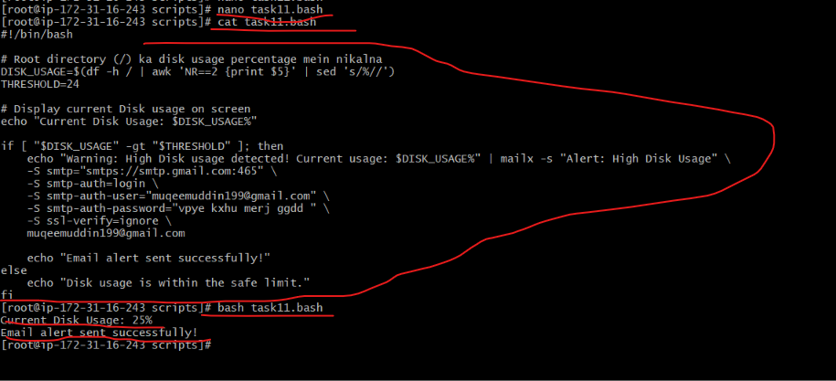
Email alert
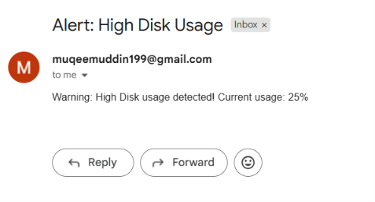

- Bash script to monitor memory and if it is more than 80% then send email notification.
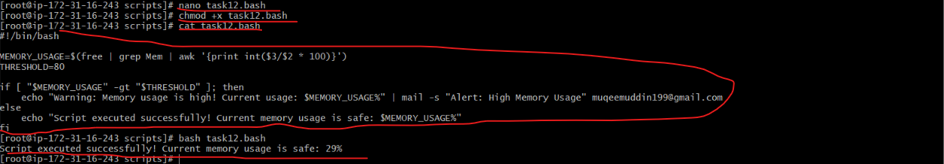

Example 2 : my actual memory usage is just 26% so reduce the percentage from 80% to 26% to receive an email :
Install mailx service to get an email
Then followed this steps so that i can get a email :

Important Note for AuthPass:
Here, you do not need to enter your normal Gmail password. Due to security reasons, Google requires an App Password:

- Go to your Google Account settings -> Security.

- Turn ON 2-Step Verification.

- Search for App Passwords and generate a new password (e.g., abcd efgh ijkl mnop).

- Enter that 16-character code after AuthPass=.

Then paste this script in my bash script file:
#!/bin/bash

# Memory usage percentage mein nikalna
MEMORY_USAGE=$(free | grep Mem | awk '{print int($3/$2 * 100)}')
THRESHOLD=25

# Display current Memory usage on screen
echo "Current Memory Usage: $MEMORY_USAGE%"

if [ "$MEMORY_{U}SAGE"-gt"$THRESHOLD" ]; then
echo "Warning: High Memory usage detected! Current usage: $MEMORY_USAGE%" | mailx -s "Alert: High Memory Usage" \
-S smtp="smtps://smtp.gmail.com:465" \
-S smtp-auth=login \
-S smtp-auth-user="muqeemuddin199@gmail.com" \
-S smtp-auth-password="vpye kxhu merj ggdd " \
-S ssl-verify=ignore \
muqeemuddin199@gmail.com

echo "Email alert sent successfully!"
else
echo "Memory usage is within the safe limit."
fi

Then executed the script so got mail as well as result on my terminal
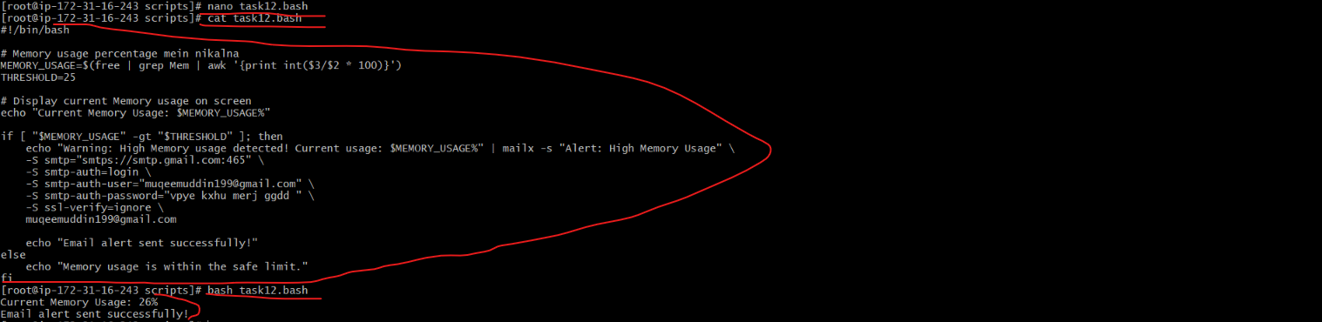
Email alert
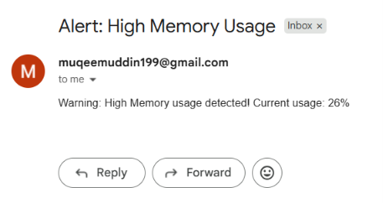

Exercise: Crontab Entries
- April 5th Midnight
- 5th of Every November, January, June if it is a Thursday
- At 05 and 27th minutes of 9, 10, 11 hours every day
- 34 minutes of 9th hour on 15th August
- Every midnight
- Every Weekend (Saturday night 11:59 PM)
- After every reboot
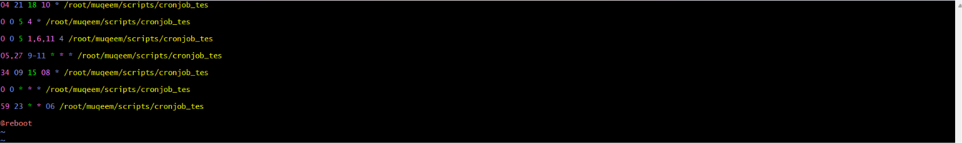
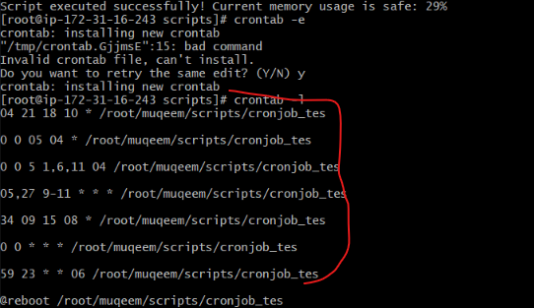
Notes
- All the scripts need to be executed on Amazon Linux EC2.
- Document all the tasks and also push the tasks to a GitHub repository (explore this for now).
- Share the document and GitHub Repo URL once done for evaluation.

